 | Mayrung Public School  Newsletter  Phone 5882 4243 Fax 5882 4326  e-mail: Mayrung-p.School @det.nsw.edu.au
 |  |  |  | Week 6, Term 4
Dear All,

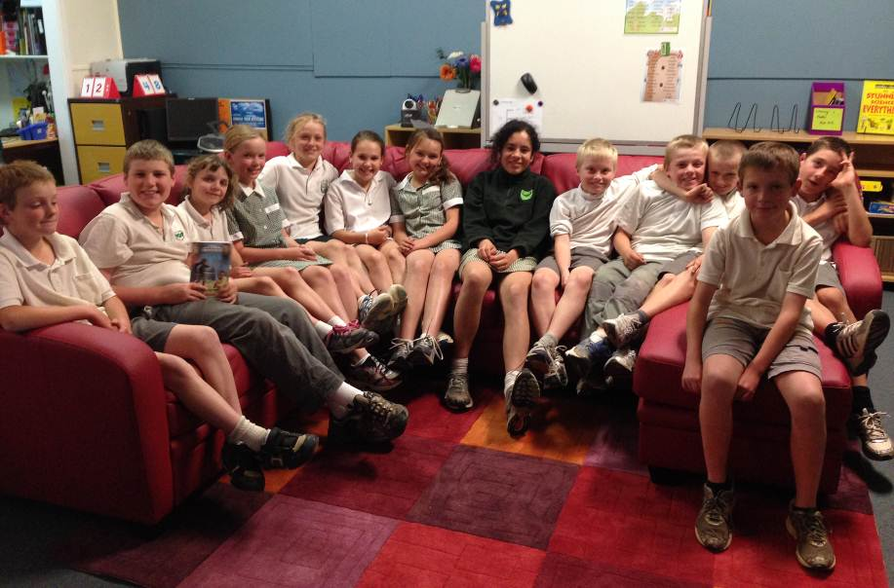
Stages 3 are presently sitting in a freshly painted classroom, which looks smart and fresh. They have all given the new colour scheme thumbs up.
Watch out Stage 2 your room is next! Thanks go to Birgit, Ben and Ted for their efforts in completing this task.
Dennis and Nicole Jansen came out last Monday to scrape around the existing concrete slab, in readiness for the containers to arrive. Whilst digging an even path for the container truck, Dennis came upon a rather angry snake, which was promptly put to sleep. This brings home the danger of snakes and although we haven’t as yet seen any on the school premises, it is necessary to be aware of their existence. At school we hold regular snake and fire drills and educate the children in how to behave under such circumstances.
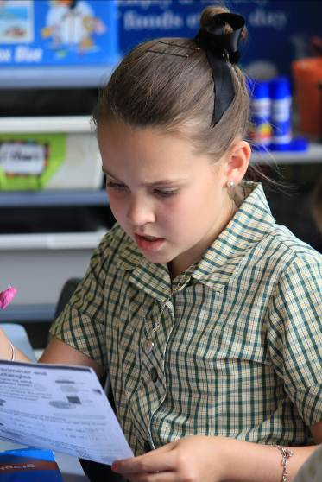
Yesterday l had the privilege of spending a majority of the day with our Year Six students. The students began their day experiencing a 2 hour transition session at the Deniliquin High School. During this time the students were introduced to their year advisor for 2014 and attended a number of classes at the High School. We then had lunch at Mac Donald’s, followed by a writing session at Regional Office, developing their Presentation Night speeches. I was very impressed with the behaviour of the students and their level of maturity. A full day visit to the High School, along with all of the Deniliquin Year sixes is scheduled for the 3rd of December.
I would like to welcome our new Year 5 student, Dana Moore, to our school. Dana has joined her brother Keidis (Yr 1), who began at the beginning of the term. I am sure that Dana will enjoy what our school has to offer and will in return be an excellent asset to our school.
On a sadder note l’m sure you will all join me in sending our condolences to Brendan Smith and his family for the sad passing of his mother, Lisa. Brendan has the support of his fellow students at school, along with the staff and is showing great strength during this time. Our thoughts also go to Gail and Jim Howitt who are doing an excellent job guiding Brendan and his siblings through this tragedy.
If anything events such as the one above make us realise how lucky we are and that we should never take things too much for granted.

Enjoy your children!

Julie Eason

Children must be taught how to think, not what to think.

Important Dates
Day | Date | Details
 | 25th November –  6th December | Swimming sessions in town
Tuesday | 3rd December | Full Day High School Orientation
Wednesday | 11th December | Presentation Night
Wednesday | 18th December | End of Term 4 - Fun Day @ Echuca combined with  Blighty and Conargo School

News form K-2:
Hi everyone,
Here we are at the end of week 6.
We had our final Kinder Orientation on Thursday, they have been fantastic and we are all looking forward to having them with us next year.
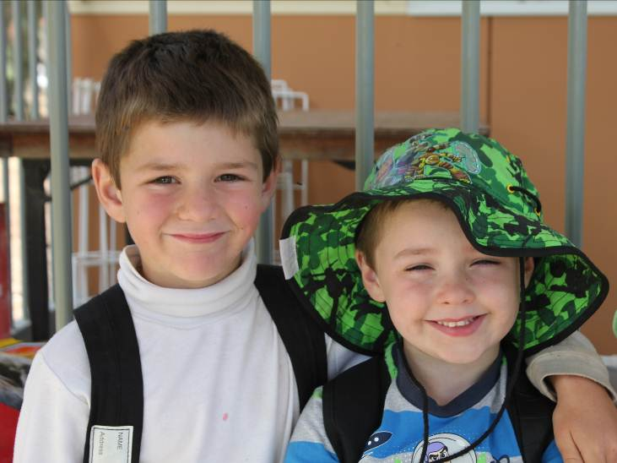

I have glued most of the base of the igloo and we are now ready for assistance in putting it together.
We are going to be very busy for the rest of the term with Production practice, swimming and report writing.
I would like to thank Nicole Jansen for helping to cover the new readers that we have purchased to be used during Reading Activities.
Thanks,
Jenny Adamson

Shots around the school:

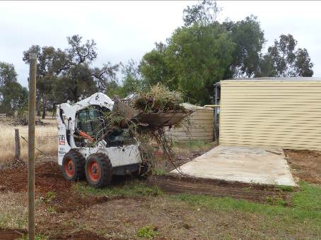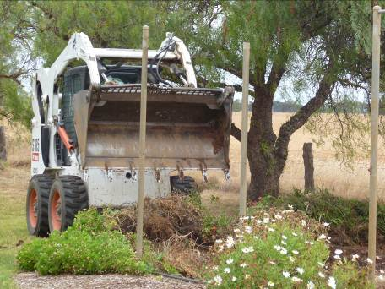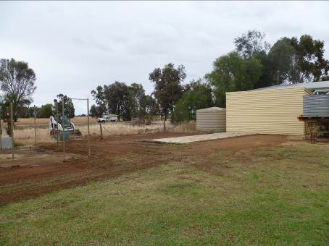
A big Thank you to Denis for donating his valuable time and equipment to prepare the ground for the storage we are eager waiting for.

The roster for the rest of this Term’s canteen:

Date | Family 1 | Family 2
29th November | Wooden | Jansen
13th December | Loader | Macdonald

If you can’t do canteen could you please find somebody else and let the school know. Thank you.

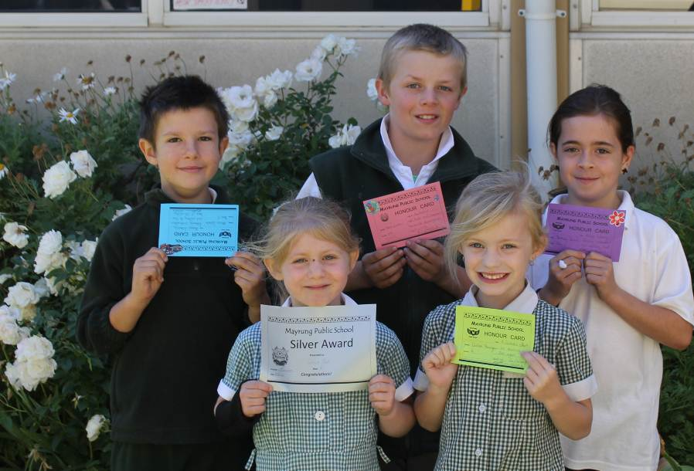

This week’s
Awards Recipients

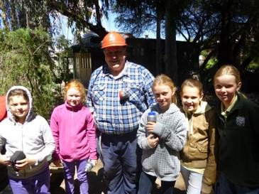
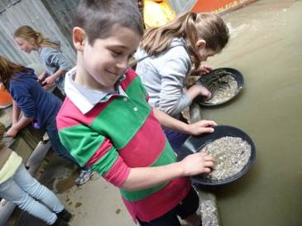
Yr 3 – 6 New:
Last week the stage 2 students went on their annual camp. This year it was Ballarat and Sovereign Hill. All the students displayed fantastic behaviour and represented small schools with great pride, I was very proud when the public commented on their behaviour. Well done to all the children.
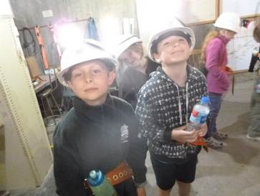
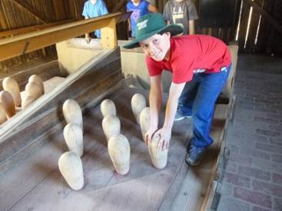
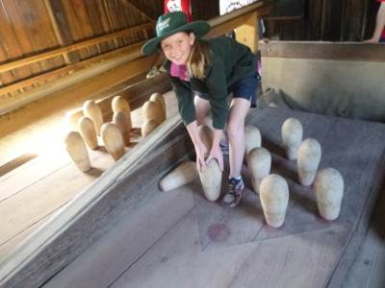
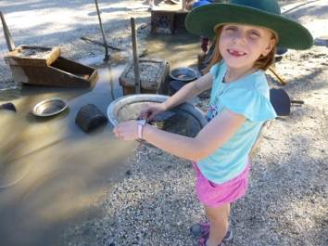
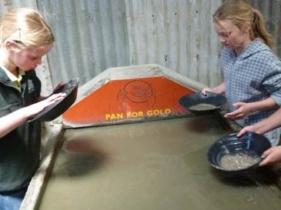
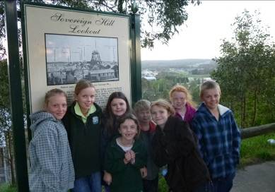
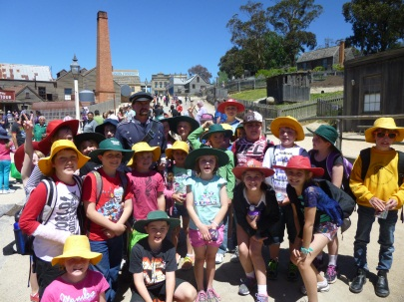
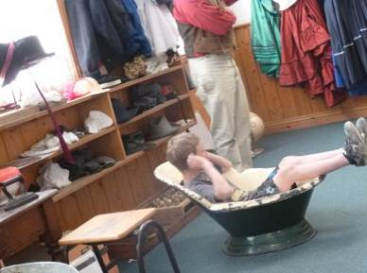
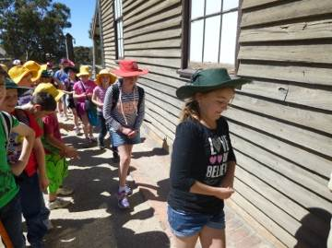
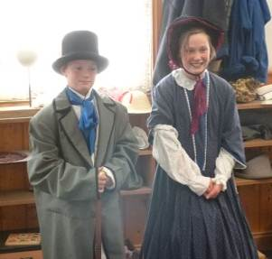
Here are some snap shots of our wonderful three days.

Next week the stage 2 students will be attending the super 8’s cricket, combining with Conargo it is always a fun day. On Thursday the stage 3 students will get their turn.
Then in week 8 the intensive schools learn to swim program will commence with more information to come next week so keep on asking your children for those notes.
A full, fun packed term still ahead so have a great restful weekend.
Thanks
Stacey O’Meara
Canteen Meeting:
A big big Thank you to Bec Strong for running the canteen for the last 6 years. We appreciate the work and enthusiasm Bec has put into running it, especially when nobody else was putting their hand up.
Thank you to Rosa Mullens, Bec Strong, Kristy Hetherington, Nicole Jansen, Tarria Moore and Lynda Barclay for revising our Canteen procedures and menu list. Please find attached the new canteen ordering procedure details attached to the newsletter. We will reinforce the new way of ordering and if your child has no money no canteen food will be given out.
Changes to the canteen menu etc has to be passed by the committee before it can take place.

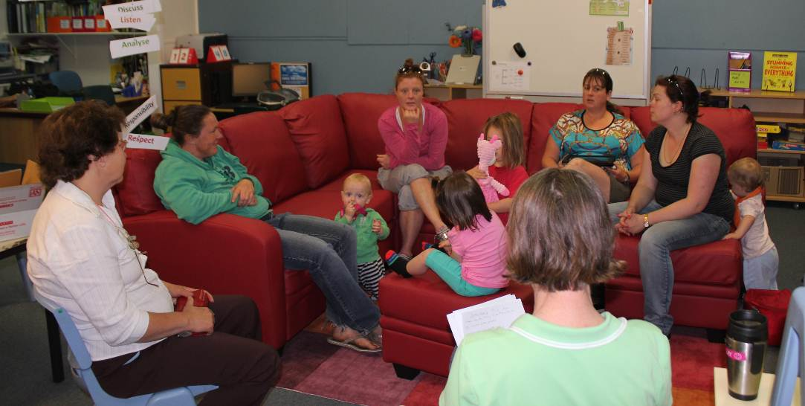

Exciting news: There will be a new canteen menu on offer next year.

Milk Bottle Igloo:
Could you please indicate below and send it back to school if you are/aren’t available to help out. It will be quite a big project and the students and staff can’t do it by themselves, we need parental involvement as well.
If we don’t get enough volunteers we might have to shelf this project.
If you want to have a look at how it is done please log onto this web address: thank you http://www.youtube.com/watch?v=MdHBY2Axqdw
How to Build a Milk Jug Igloo - Midland Christian School
Scholastic Book Order:
Please find attached a Scholastic Book Club Order. If you would like to order please have your order in by next Friday. Please remember to pay via CreditCard or cheque written out to Scholastic.
Igloo Project
Name ______________________

I am able to help out yes no (please circle)

Monday Tuesday Wednesday Thursday Friday

Week 7 8 9

would suit me (please circle)

Please consider coming and helping out, your child will love your involvement and you can get an insight in what is going on at the school.

